**Mini-NS FSW Test Macro Instructions**

A test macro has been provided to test the Mini-NS inputs and outputs. This macro issues commands to the Mini-NS and records the output packets via TeraTerm. The result of this procedure is a set of data files in ASCII text format which can be plotted/visualized with Origin and a text file containing the output packets.

1. Terminology 2

2. Requirements 3

3. Run Instructions 4

3.1 Before Running the Macro 4

3.2 Macro Run Instructions 4

4. Appendix 14

# Terminology

Mini-NS – the Miniature Neutron Spectrometer

FSW – Flight Software

JTAG – JTAG Programming Cable

V4– V4 FSW for the Mini-NS

TT – Tera Term terminal program

Workspace – the directory on the user’s computer where the macro is located

XC/XQ – The Zynq processors used on the Engineering/Flight boards, respectively

APID – A value used to identify the type of a Mini-NS CCSDS packet

USB-RS422 adapter – A cable used to connect the Mini-NS RS-422 to a serial port on the computer

# Requirements

To run the Test Macro, you will need the following software:

* Tera term terminal program – to talk with the Engineering board
* Spreadsheet editor (Microsoft Excel, etc)
* A text editor program
  + RMD uses the program “Notepad++”, [here](https://notepad-plus-plus.org/download/v7.6.3.html)
* An engineering board with XQ processor programmed with V4 FSW

The hardware necessary for running this test is:

* Engineering board
* Xilinx JTAG Programming cable
* USB-to-RS-422 converter cable
* Power supply
* SD cards x 2
* SD card reader
* Computer to run the software above

# Run Instructions

## Before Running the Macro

The process described by these steps will guide the user through running the TT macro, “V4 Checkout Det 0-DAQ.ttl” and “V4 Checkout Det 0-WF.ttl”, which will run the Engineering board through a set of tests which exercise the capabilities of the V4 FSW.

This process assumes the following items are complete:

* The user has a working Mini-NS Engineering board with the V4 BOOT files properly programmed into the EEPROM via the document “Loading Instruction Set onto Flight Board EEPROM v1.0”
* The user has TT or a suitable terminal interface program installed
  + A suitable alternative must accept “.ttl” files
  + A variable baud rate is also potentially useful
* The user has 2 SD cards to use with the Engineering board, one to be placed in each of the SD card slots, J3 (SD card 0) and J7 (SD card 1). The planned size for the SD cards is 32 GB.
  + The engineering board will only interface with specific types of SD cards; the ones provided by RMD are the ideal SD cards to use

## Macro Run Instructions

1. If you already have the V4 FSW downloaded from GitHub, skip to step 4, as you followed steps 2-3 while programming the board with the BOOT files.
   1. Before moving on, ensure that the directory where the FSW was downloaded is available.
2. Go to github ([link](https://github.com/RMDInc/LunaH_XC_FSW)) and download the project “LunaH_XC_FSW”.
   1. Click “Clone or Download”
   2. Click “Download Zip”

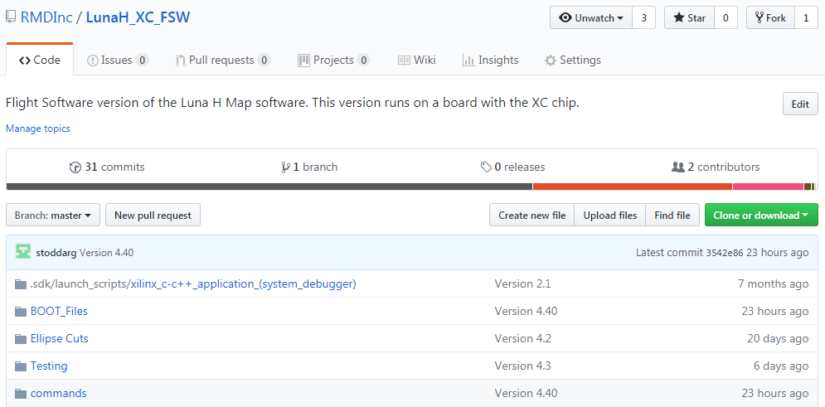

1. Unzip the data to a convenient and accessible location on your computer. The location is not important for the purposes of this document.
   1. The folder “Command Macros” contains an archive folder and another called TT Macros, which holds the command macros for each Level release of the FSW. We are interested in the V4 folder, which has the macros for V4.
   2. The “README.md” file contains version information for the rest of the code.
   3. The various other folders contain the source code for the instruction set.
2. Open the folder: Workspace > Command Macros > TT Macros > V4 to reach the macro for testing the V4 FSW
   1. The file “V4 Checkout Det 0-DAQ.ttl” and “V4 Checkout Det 0-WF.ttl” files are what will be loaded into TT to test out the FSW
   2. There are a couple of executable files in this folder,
      1. “V4 Output Packet Reader.exe”
      2. “V4 Data Product Reader.exe”
   3. These will be run after running the TT macro to process the results of the runs.
3. Modify the Macros to the correct save file path
   1. Open the file macro file, “V4 Checkout Det 0-DAQ.ttl”, in a text editor
   2. Find the line which starts with "logopen" followed by a file path
      1. This should be line 10
      2. This is where the log file to hold the data packets will be generated
   3. Change the file path to the folder in step 4:
   4. ‘C:\my\path\Command Macros\TT Macros\V4\ V4_MACRO_OUT_DAQ.bin’
      1. The path must be put between single quotes: 'C:\my\path\V4_MACRO_OUT_DAQ.bin'
      2. The path must use forward slashes \ \ \ between the folders
      3. The name for the file is given at the end of the path; the name that should be used is: “V4_MACRO_OUT_DAQ.bin”, as seen above
   5. Now the line should be:

logopen 'C:\my\path\Command Macros\TT Macros\V4\V4_MACRO_OUT_DAQ.bin' 1 0

* + 1. the command is "logopen" and there are three arguments:
       1. The file path
       2. 1
       3. 0
  1. Save the file and exit the text editor
  2. Open the file macro file, “V4 Checkout Det 0-WF.ttl”, in a text editor
  3. Repeat steps b-f with the output file being V4_MACRO_OUT_WF.bin

1. Plug the USB-RS422 adapter into the computer’s usb port
2. Open TT
   1. Connect to the USB-RS422 adapter via the port it is plugged into
      1. If TT connects automatically, skip to step b, below, otherwise continue
      2. File > New Connection
      3. Press the radio button next to Serial and choose the appropriate port

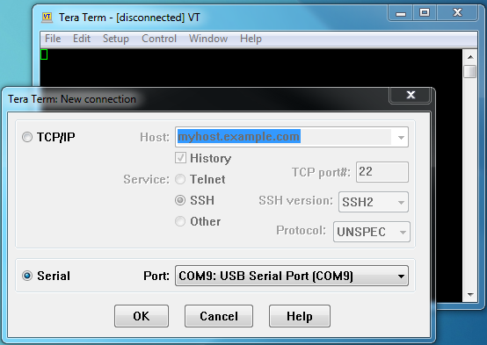

* 1. Open the setup options by clicking: Setup > Serial Port
  2. Verify the settings listed below
     1. Baud Rate = 921600
     2. Data = 8 bit
     3. Parity = None
     4. Stop = 1 bit
     5. Flow Control = None
     6. Transmit Delay = 0 msec, 0 msec
  3. Click OK

1. Prepare the SD cards
   1. Attach yourself to a grounding strap
   2. Ensure that power to the board is off
   3. Slide back the metal lid for the SD card holder
   4. Remove the SD card
      1. See below

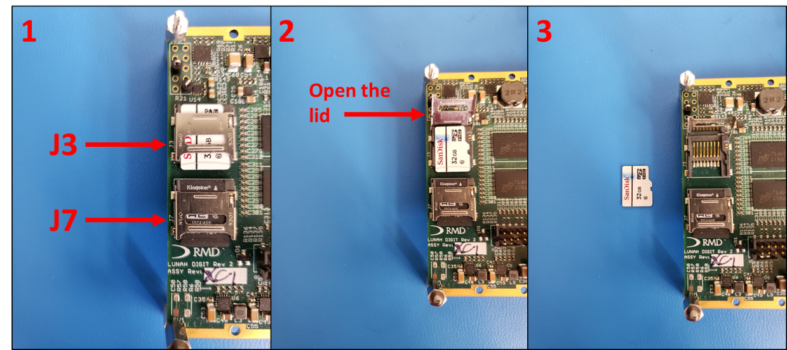

1. Delete files from the SD Card
   1. Plug the SD card into an SD card reader
   2. To ensure that the files created by the board are new for this run, delete the following files:
      1. MNSCMDLOG.txt
      2. MNSCONF.bin
   3. This will cause the system to create these new during the test and we can validate them
   4. Eject the SD card from the computer
   5. Remove the SD card from the reader
2. Replace the SD card
   1. Attach yourself to a grounding strap
   2. Ensure that power to the board is off
   3. Slide back the metal lid for the SD card holder
   4. Place the SD card gently back into the holder
   5. Push down on the metal lid and slide it closed on top of the SD card
3. Repeat Steps 8-10 with SD card 1 (J7) except
   1. When deleting files from SD card 1, the file to delete is:
      1. MNSCMDLOG.txt
4. Power on the board
   1. +12 V to the engineering board
   2. Ensure that both the green "Power Good" and "Done" LEDs are illuminated
   3. Once the system boots, it is now running and packets will begin to show up on TT; they can be ignored, the system is working as normal
5. From the TT file tab choose
   1. Control > Macro
   2. A file explorer window will pop up, navigate to the location where you unzipped the files from GitHub
   3. Go to the folder:
      1. Workspace > Command Macros > TT Macros > V4
   4. select the file V4 Checkout Det 0-DAQ.ttl

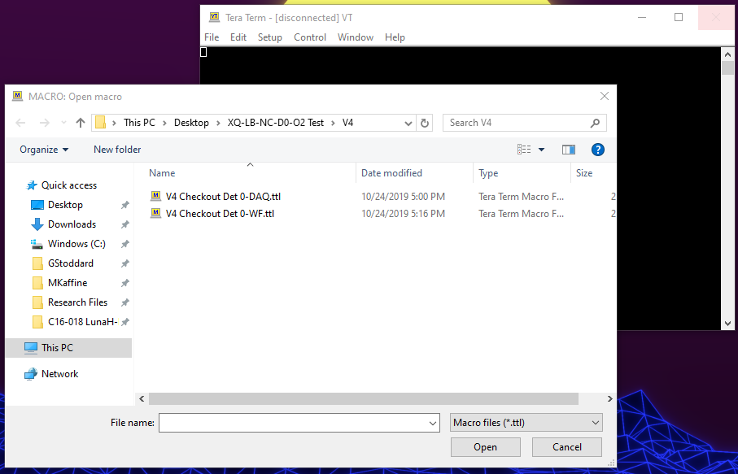

* 1. Click “Open” to have TT load the macro
  2. The macro will load automatically and TT will start it
  3. When the macro starts, TT will minimize itself and pop up a small box:

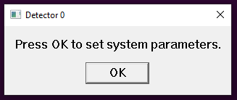

* 1. The TT macro is now ready to run.

1. Press OK to start the test
2. This will start issuing commands to the board and collecting the output.
3. A secondary box will pop up, see below:

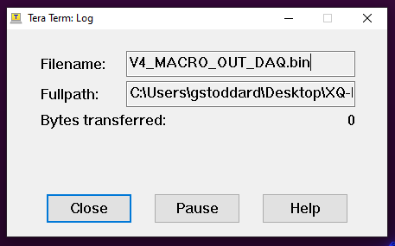

1. This box shows the TT Log and tells you how many bytes have been recorded so far. The bytes transferred number should be incrementing
2. Also shown is the Filename and path to where the log file is being saved.
3. The test takes around a few minutes to run and needs periodic clicks.
   1. The pop-up boxes will give brief instructions including the following:
      1. “Press OK to move to …” indicates that the system will be moving to another state when the OK button is pressed
      2. “Wait until the system has returned to Standby, then press OK” indicates that the user should wait until the current draw has dropped to its nominal level (~0.15 Amp or so) and/or the SOH Mode Byte indicates the system is in Standby Mode again
      3. “Press OK to transfer … file” indicates that the next command will be a transfer command. It is important to check the “Bytes transferred:” box in the TT Log Window to make sure it is not rapidly increasing before pressing OK to request another transfer.
      4. “Press OK when the transfer has finished” is the same idea as the above instruction.
   2. The log window will close automatically after pressing OK on the window which says “Press OK when the transfer has finished”
   3. The TT window will stay minimized.
4. Restore the TT window and verify that packets are still appearing there
   1. The packets which appear may look like the following:

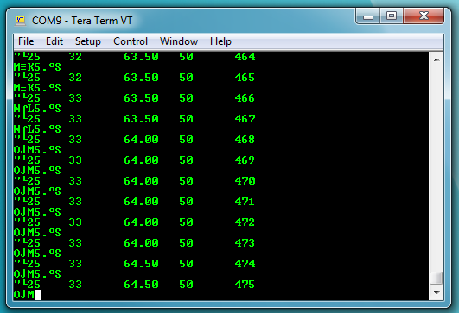

1. Power cycle the board
   1. Remove +12 V to the board
   2. Ensure that both the green LEDs are not illuminated
   3. Wait a moment
   4. +12 V to the board
   5. Ensure that both the green " LEDs are illuminated
2. Repeat steps 13-14, then go to step 19
   1. This time select the file V4 Checkout Det 0-WF.ttl from the TT window
3. The test takes around a few minutes to run and needs periodic clicks.
   1. The pop-up boxes will give brief instructions including the following:
      1. “Press OK to move to Collect Waveforms” indicates that the system will be moving to Collect Waveforms state when the OK button is pressed
      2. “Press OK when the SOH mode byte returns to Standby” indicates that the user should wait until the current draw has dropped to its nominal level (~an Amp or so) and/or the SOH Mode Byte indicates the system is in Standby Mode again
      3. “Press OK to transfer … file for the test” indicates that the next command will be a transfer command. It is important to check the “Bytes transferred:” box in the TT Log Window to make sure it is not rapidly increasing before pressing OK to request another transfer.
      4. “Press OK when the transfer has finished” is the same idea as the above instruction.
4. Restore the TT window and verify that packets are still appearing there
   1. The packets which appear may look like the following:
5. Turn off the board
   1. Remove +12 V to the board
   2. Ensure that both the green LEDs are not illuminated
6. Retrieve the SD Card 0 (J3) from the board
7. Attach yourself to a grounding strap
8. Ensure that power to the board is off
9. Slide back the metal lid for the SD card holder
10. Remove the SD card



1. Retrieve files from the SD Card
2. Plug the SD card into an SD card reader
3. There should be at least 2 files and a number of folders on SD card 0:
   * 1. MNSLOG.txt
     2. MNSCONF.bin
     3. I0007_R0001\
     4. WF_I10\
     5. WF_I11\
4. Copy the contents of the SD card into the folder with the test macro:
5. Workspace > Command Macros > TT Macros > V4
6. The contents of the V4 folder should now be:
7. MNSLOG.txt
8. MNSCONF.bin
9. I0007_R0001\
10. WF_I10\
11. WF_I11\
12. V4_MACRO_OUT_DAQ.bin
13. V4_MACRO_OUT_WF.bin
14. MNS Checkout Det 0-DAQ.ttl
15. MNS Checkout Det 0-WF.ttl
16. V4 Output Packet Reader.exe
17. V4 Data Product Reader.exe
18. Double click the V4 Output Packet Reader executable to launch it.
19. It will ask for the name of the file to be translated
20. Enter the file name: V4_MACRO_OUT_DAQ
21. The executable will write brief information to the TT screen to inform you of how the processing is going. The screen will look like this:

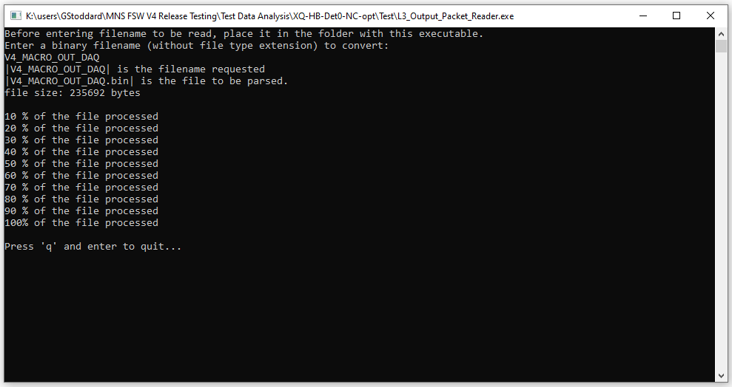

1. There will be 6 files produced by the packet reader executable for the V4 DAQ macro:
   1. 2dh_1_7_1.bin
   2. 2dh_1_7_1.bin
   3. 2dh_1_7_1.bin
   4. cps_7_1.bin
   5. evt_7_1.bin
   6. V4_MACRO_OUT_DAQ_PACKETS.txt
2. The _PACKETS.txt file contains all the information from each packet transferred from the board during the macro operation.
3. Run the V4 Output Packet Reader executable again
4. Enter the file name: V4_MACRO_OUT_WF
5. There will be 4 files produced:
   1. wf_10_0.bin
   2. wf_11_0.bin
   3. wf_12_0.bin
   4. V4_MACRO_OUT_WF_PACKETS.txt
6. Now all of the transferred data product files have been created.
7. The next step is to run the V4 Data Product Reader executable on each of the data product files that were produced in step 23 and over the files that were copied from the SD card.
8. Process the data files into data product files
   1. Double click the V4 Data Product Reader executable to launch it.
   2. Enter the name of the file to be processed without the .bin file extension and hit enter
   3. Depending on the file type, the macro will display run information from the file when it finishes processing. Hit enter to close the macro
   4. Repeat steps a-c with all the data files produced by step 10 above
   5. This will result in a set of _translated.txt versions of each file that is processed
      1. The EVT file will also create an EVT_2DH and PMT_2DH text file which can be compared to the real 2DH files.
   6. Move the executable into the same folder as the SD card data files\
   7. Follow steps a-c with each file
      1. If only one module was run as part of the test, just process that specific 2DH file, the other three will be empty (all 0’s)
      2. Only one or two of the EVT files needs to be processed unless a full comparison with the CPS is being done
9. Analyze the transfer of data files from the board
10. Plot the results

# Appendix

Include sample files and perhaps breakdowns